Addingham Civic Society Environment Group
Update for the Parish Council Meeting on Wednesday 18 December 2019
Hoffman Wood Field, Memorial Recreation Ground & Gala Field and New Sites
For information and discussion
Hoffman Wood Field- Wildlife Margins
- The grass margins were cut by Bradford MDC in September as requested.
- AEG volunteers raked off the grass, and BMDC collected the piles.
- On the bank next to Church Street, AEG volunteers have planted wildflower plug plants and transplants, and sown patches of yellow rattle (a useful plant which helps to supress the dominant grasses).
- The Woodland Trust Hedge Pack for the new hedgerow on the eastern boundary has been ordered and will be delivered in March. In the meantime, at the end of November AEG volunteers started planting some of the hedge with our existing stock of saplings.

Memorial Recreation Ground & Gala Field

- The wet weather delayed the cutting of the triangle in the bottom corner. BMDC finally managed a cut in the last week in October. AEG raked off the grass and sowed yellow rattle on 9 November.
- The MUGA bank has been partially cut and the grass raked off by AEG volunteers. Ox eye daisy transplants were planted at the 9 November work party.
- A Woodland Trust Hedge Pack has been ordered for delivery in March, to extend the hedgerow adjacent to Stockinger Lane, in the Scout HQ garden which we planted with the Cubs in Autumn 2018. The hedge has established well, and we will arrange a planting day in the Spring with the Scouts/Cubs to put in the second length.
- BMDC cut the bank alongside the football field in September, and AEG volunteers raked the grass off for the Council to collect. We also dug out docks at the Pavilion end. The bank is already quite floristically diverse, so no supplementary planting is planned here.
Reducing the use of herbicides in the management of Addingham’s green spaces
AEG is working with Addingham Primary School to help manage the woodland corridor around the perimeter of the school site as part of the ‘Green Heart of the Village’ project. The BMDC Footpaths Team has removed spraying from the edges of the “public right of way” path next to the woodland going forward. Excessive and continuing use of herbicide in such locations kills wildflowers and may encourage the growth of more vigorous undesirable plants such as mare’s tail. The Footpath team also sprays other surfaced footpaths in Addingham parish. They would be prepared to stop this practice and manage the margins by strimming.
Bradford Council’s Parks & Countryside Department have told us that they would be open to minimising the use of chemicals and take a more nature friendly approach to weed control around mature trees, obstacles and grass edges for next season in recreation areas that they manage for the Parish Council.
In our management agreement for Hoffman Wood Field wildflower and hedgerow margins, approved by the Parish Council in April, we have already agreed that BMDC should be instructed not to spray around the mature trees or the stone walls on the north and south boundaries.
At the Memorial Recreation Ground, we note that BMDC sprays the bottom of the MUGA Bank, around the mature trees, the base of the picnic tables and the wooden children’s play trail. As well as being detrimental to wildlife, there are also health concerns for humans and pets from the continued use of herbicide. Bradford Council’s Tree & Woodland Manager advocates stopping spraying around mature trees as standard practice, together with allowing grass to grow long under the canopy to benefit both wildlife and tree health.
AEG requests that the Parish Council considers and approves a herbicide free management policy for Addingham’s greenspaces and authorises the Clerk to liaise with BMDC Parks & Countryside Service to agree protocols. We recommend especially that the practice of spraying around mature trees, and edges adjacent to wildflower and pollinator patches and next to footpaths in wildlife green corridors throughout the village is stopped.

New sites

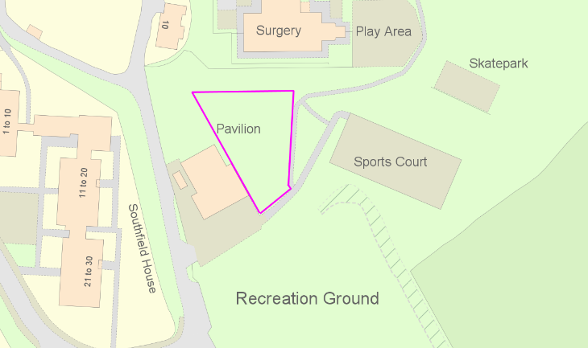
- The area between the medical centre and the Scout HQ, to the west of the path to the Gala Field is not one of the areas that AEG undertook to manage. It was left to grow on this summer with a grass path cut through by the Council. Unfortunately, this area is very full of docks. We were asked to advise on what to do about this and suggested that regular mowing by BMDC should be reinstated, while a longer-term plan for this area is considered. The concentration of docks in this area suggests the ground is very nutrient rich and so we think establishing a wildflower rich meadow is going to be difficult. An alternative, which would also benefit pollinators and improve this area, would be to establish a community orchard here. If this of interest to the Council, AEG would be pleased to take this forward and put together a proposal.

- We are continually being urged to plant more trees to help combat climate change. AEG is now holding a stock of saplings on its allotment at Lower Stamp Hill ready to be planted out in the village over the winter. Some of these have been used in creating the new hedge in Hoffman Wood Field as described above. Others could be planted elsewhere on Council-owned Green Spaces. AEG would also be pleased to suggest areas that might be planted should the Council so wish and proposes a walk-over with interested Council members to discuss possibilities at the Memorial Recreation Ground and Silsden Road. Coincidentally, AEG recently received a suggestion from a local resident for planting at Silsden Road which we think has great merit (see annexe 1).
Jan Hindle/Rick Battarbee
AEG Steering Committee 12/12/2019
Annexe 1

I am sure tree planting in the village is an issue which the environmental group will already be giving some thought to but just wanted to put forward an idea for consideration:

The recreation area at the top of the village (adjacent to Silsden Road) suffers most of the year from being very boggy and is under-used as a recreation area because of this. There is a token football area but it is hardly ever used because of the ground condition and the fact that it slopes considerably. This area would benefit greatly from some more tree planting to both help with the drainage and also create a woodland facility for everyone to enjoy.

The line of trees along the edge and copse area (planted a few years ago) have become popular with dog walkers and young children use this space for games/dens but it is a very small space. Older children are starting to try and use it for a mountain biking track, though this is causing more problems due to the ground condition but a properly designed trail would be a great addition.

The Rec is such a large open space it must have the potential to be a fabulous woodland area with trails which could be enjoyed by bikers, walkers, runners and young explorers alike. Obviously careful thought would have to be given to the design and area to be planted along with appropriate consultation, especially of the houses on Moor Park Drive (which back onto the Rec field) to ensure they were not adversely affected.

It could be a fabulous community project where local people could buy and plant their own tree(s) creating an even greater sense of ownership. Many families regularly use Middleton Woods and Hebers Gill Woods in Ilkley to have fun with their children and dogs - it would be great to create our own smaller version in the village, and improve our carbon footprint at the same time.

I’m sure you must get lots of suggestions so apologies if this has already been considered, or if there are reasons why it is not possible. However, every time I squelch through the sodden, empty recreation field I think of how much it could be improved by some further tree planting and, with a bit of thought, what a fabulous community resource it could become.

